**USER’S MANUAL**

***Checkers Board Game***

**For Android**

**Dylan Detillier**

**Christopher Schilling**

**Bijay Regmi**

**Brandon Phillips**

[**https://github.com/cschilli/checkers-android**](https://github.com/cschilli/checkers-android)

**USER'S MANUAL**

**TABLE OF CONTENTS**

Page #

1.0 GENERAL INFORMATION 3

1.1 System Overview 3

1.2 Authorized Use Permission 3

1.3 Contact information 3

1.4 help desk 3

2.0 SYSTEM SUMMARY 4

2.1 System Configuration 4

2.2 User Access Levels 4

3.0 QUICK START GUIDE & Features 5

3.1 Launching the application 5

3.2 Main Menu 5

3.2.1 Play Game 5

3.2.2 Load Game 5

3.2.3 Exit 5

3.3 Game Play 6

3.3.1 Game Mode 6

3.3.2 Player Color 7

3.3.3 Game Board 8

3.4 Save/Load Game Functionality 9

3.4.1 Save Game Feature 9

3.4.2 Load Game Feature 10

3.5 Restart/Quit Match *11*

3.5.1 Restart Match 11

3.5.2 Quit Match 12

3.5.3 Match Ended Dialog 13

3.6 Exiting the Application 14

3.7 Reporting Any Bugs 14

# GENERAL INFORMATION

## 1.1 System Overview

Checker for Android OS is an application that lets users play the popular board game, Checkers, on their Android OS-based device. The application was developed in Android Studio using the Java programming language and XML. The application is designed for touch screen devices running the Android OS.

## 1.2 Authorized Use Permission

Alteration or unauthorized distribution of this software application is strictly prohibited.

## 1.3 Contact Information

**Name:** Dylan Detillier **Email:** ddetilli@uno.edu

**Name:** Christopher Schilling **Email:**

**Name:** Bijay Regmi **Email:**

**Name:** Brandon Phillips **Email:**

### 1.4 Help Desk

For any concerns regarding this application, please contact any of the above contacts posted above.

# SYSTEM SUMMARY

## 2.1 System Configuration

This application requires storage space for installation. Internet connectivity is not needed except for installation of the application. Enough storage is needed for the Save/Load functionality feature of the game.

## 

## 2.2 User Access Levels

This application can be used by one user or two users using the device that has this application installed. Save files are stored on the OS’s root storage device. This application does not access any external features.

# QUICK START GUIDE

## 3.1 Launching the Application

The user can simply launch the application after installation. There are no other requirements for the user to take before launching the application.

## 3.2 Main Menu

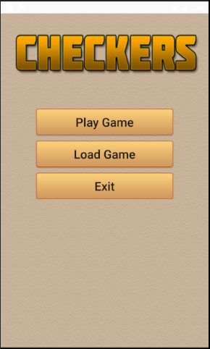

**3.2.1 Play Game**

The “Play Game” button will start the game for the user.

**3.2.2 Load Game**

The “Load Game” button will load a user’s saved game only if a save file exists.

**3.2.3 Exit**

The “Exit” button will exit the application.

## 3.3 Play Game

## 3.3.1 Game Mode

Upon starting the game (pressing “Play Game” button), the user must select between two different game modes:

**1 Player Mode** – Play Checkers against the computer (automated bot)

**2 Player Mode –** Play checkers against another user

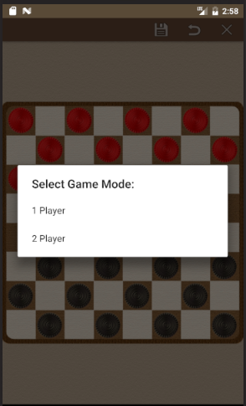

## 3.3.2 Player Color

After a game mode is selected, Player 1 must choose a color to be: Light or Dark. The player with the color Dark gets to make the first move of the game.

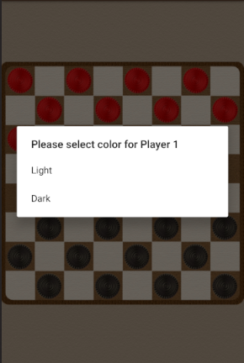

## 3.3.3 Game Board

After game mode and player color is selected, the game starts. Below is the screen for playing the game.

* When it is a player’s turn, their game pieces will be highlighted with a yellow circle:
* When a player presses a game piece, it will be highlighted with a green circle and become lighter in color:



* 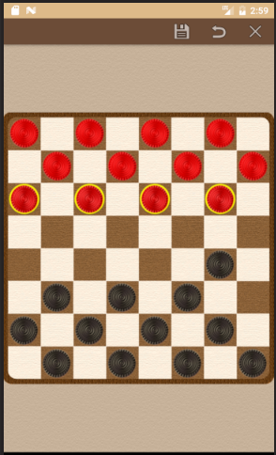The possible moves of a player are the board squares with:

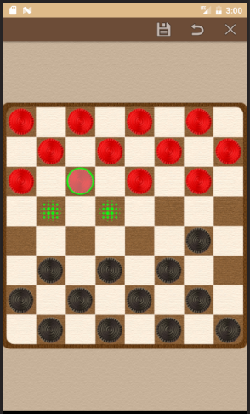

Showing Light pieces that can be moved Showing possible moves of selected piece

## 3.4 Save/Load Game Functionality

## 3.4.1 Save Game Feature

User can choose to save a game by clicking the save button at the top of the screen (circled in yellow in picture below). User must confirm to save if a save game file already exists. Game is saved to Android device’s storage.

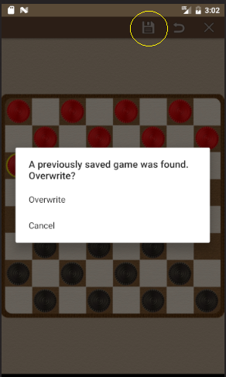

## 3.4.2 Load Game Feature

User can choose to load a saved game IF save game file exists. Game is loaded from a saved game file stored on Android device’s storage.

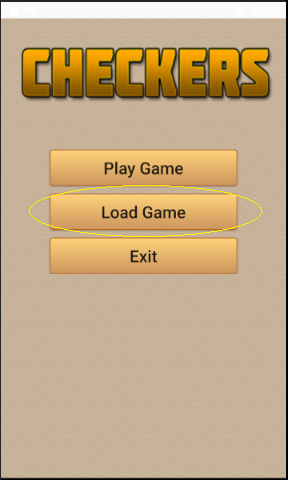

## 3.5 Restart/Quit Match

## 3.5.1 Restart Match

User can restart a match while playing a game by clicking the restart button at the top of the screen. User is prompted with confirmation menu to confirm to proceed with match restart.

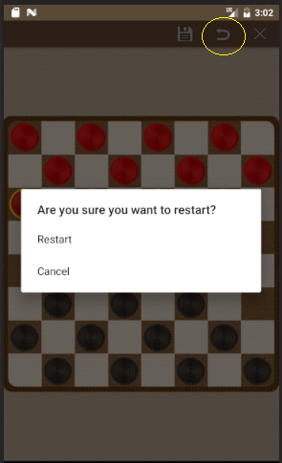

## 3.5.2 Quit Match

User can quit a match by clicking the quit button at the top of the screen. User is prompted with confirmation menu to confirm to proceed with quitting the match. If clicked, the user will be back to the main menu.

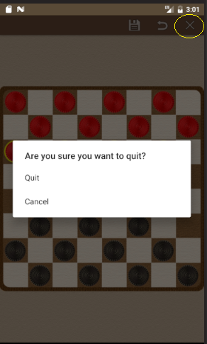

## 3.5.3 Match Ended Dialog

When a player wins or loses a match, this dialog box asks if the user wants to play again or exit to main menu.

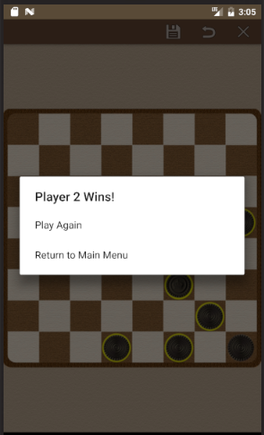

## 3.6 Exiting the System

A user can exit the application by clicking the [Exit] button in the main menu, pressing the back button on the keyboard/screen, or pressing the home button.

## 3.7 Reporting Any Bugs

Any bugs that are found can be submitted through the Android Play store.